PART 1: Think about your own identity. Write down in bullet points what makes you ‘you’. What makes you different. What are some things that someone who doesn’t know you at all needs to know about you in order to really begin to understand you. It can be facts like where you were born, the languages you speak. It can be your sex, gender, sexual orientation, whether you have a disability. Whether you are spiritual and/or religious. It can be your dreams/hopes or things you’ve accomplished. Write down at least 10 things.

PART 2: Think about your identity again and write down in point form a time when you felt misunderstood. When you felt ignored, silenced, or discriminated against. This can be at your workplace, school, university, or in your own home. Write down the circumstances and how they made you feel.

‘Don't write what you know. Write what you are willing to discover.’ Yusef Komunyakaa

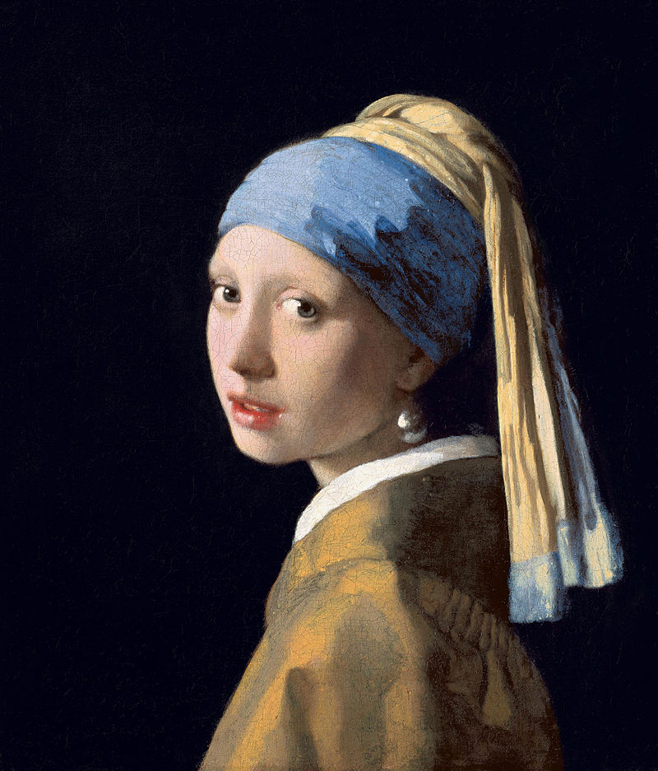
Girl with a Pearl Earring by the Dutch painter Johannes Vermeer.
Tracy Chevalier’s book Girl with a Pearl Earring (1999) was inspired by the painting. Since the girl in the painting remains nameless, Chevalier wanted to tell the story from her perspective. This was Chevalier’s way of giving the girl a name—Griet—a voice, agency, and a story.

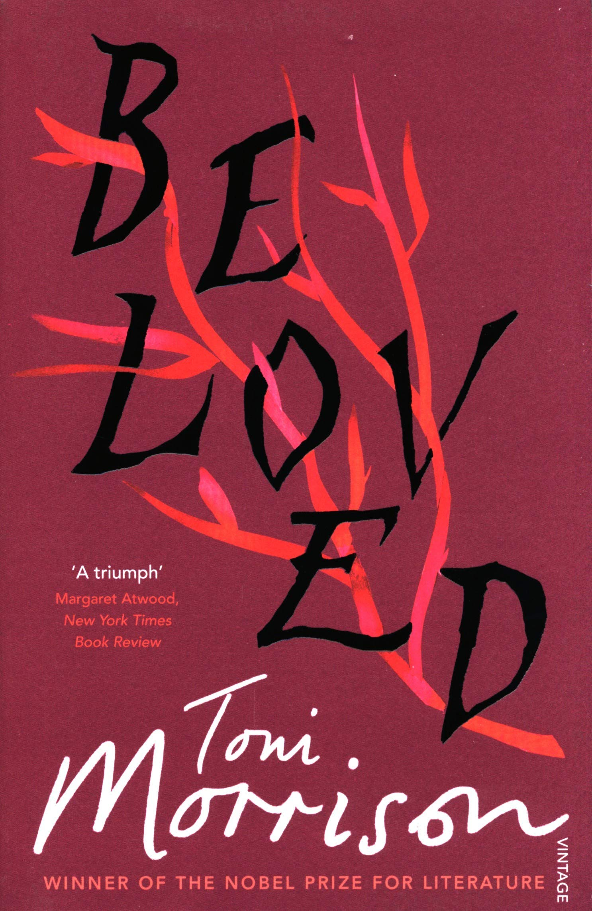
Tony Morrison’s Beloved (1987)
The shocking and devastating crime in the story actually took place—the act of Margaret Garner, a runaway slave in 1856. However, Garner died of typhoid fever in slavery and didn’t see freedom, like Morrison’s fictitious character. Why do you think Morrison chose to tell this story?

PART 3: Create a protagonist!

Character Profile Worksheet
Basic Statistics
Name:
Age:
Nationality:
Socioeconomic Level as a child:
Socioeconomic Level as an adult:
Hometown:
Current Residence:
Occupation:
Income:
Talents/Skills:
Salary:
Birth order:
Siblings (describe relationship):
Spouse (describe relationship):
Children (describe relationship):
Grandparents (describe relationship):
Grandchildren (describe relationship):
Significant Others (describe relationship):
Relationship skills:
Physical Characteristics:
Height:
Weight:
Race:
Eye Colour:
Hair Colour:
Glasses or contact lenses?
Skin colour:
Shape of Face:
Distinguishing features:
How does he/she dress?
Mannerisms:
Habits: (smoking, drinking etc.)
Health:
Hobbies:
Favourite Sayings:
Speech patterns:
Disabilities:
Style (Elegant, shabby etc.):
Greatest flaw:
Best quality:
Intellectual/Mental/Personality Attributes and Attitudes
Educational Background:
Intelligence Level:
Any Mental Illnesses?
Learning Experiences:
Character's short-term goals in life:
Character's long-term goals in life:
How does Character see himself/herself?
How does Character believe he/she is perceived by others?
How self-confident is the character?
Does the character seem ruled by emotion or logic or some combination thereof?
What would most embarrass this character?
Emotional Characteristics
Strengths/Weaknesses:
Introvert or Extrovert?
How does the character deal with anger?
With sadness?
With conflict?
With change?
With loss?
What does the character want out of life?
What would the character like to change in his/her life?
What motivates this character?
What frightens this character?
What makes this character happy?
Is the character judgmental of others?
Is the character generous or stingy?
Is the character generally polite or rude?
Spiritual Characteristics
Does the character believe in God?
What are the character's spiritual beliefs?
Is religion or spirituality a part of this character's life?
If so, what role does it play?

Creating Character Dating Profiles (examples)
This exercise can especially help writers find a character’s voice.

Name: Jay Gatsby
Age: Rather not say, old sport.
Location: West Egg.
Seeking: Daisy. Just… Daisy.
A few words about me…
I’ve got connections. Just ask Uncle Wilhelm. MidWest-born, Oxford-educated, ex-military. Old money, I swear. Teetotal.
Living the dream.
What my ideal partner would be like
A beautiful little fool. Petite, blonde, preferably an ex-debutante. Married/NSA is fine by me.
My idea of the perfect date
I will throw a party. A party like West Egg has never seen. And you will come to it, and see what I have made of myself, and finally love me again.
For the second date I will fill the house with flowers, which is not at all controlling or creepy.
Best feature
I own a lot of shirts. Really, really nice shirts. Seriously, they make grown women cry.
Biggest turn off
Poverty.
Interests
Sailing, cricket, bootlegging, big game hunting, cars.
Favourite colour: green.
That’s enough questions, old sport. I don’t like questions. Excuse me, I have to take a phone call from Philadelphia.

Name: Holden Caulfield
Age: 17
Location: New York
Seeking: Girls. Jesus. You just about drive me crazy. Even if you were sitting there, blowing your nose or scratching your arm or telling me how terrifically jaded you feel about Tinder. It’d be nice to shoot the crap. And maybe drink a goddam highball
A few words about me…
I’m about six foot two and have a million grey hairs on one side of my head. It’s true.
And if you really want to hear about it, I’m not the kind of guy who, on the first date, goes on and on about his lousy childhood or any of that eHarmony kind of crap. I don’t talk about how many crazy marathons I’ve run either or get sore and childish as hell if you beat me at ping pong in Shoreditch for God’s sake. I don’t understand those sort of guys, I really don’t. Maybe they’re all secretly terrific dancers or something. But just to warn you, I have one of those loud, very stupid laughs and I can be sarcastic if I’m in the mood. I mean, if I ever had to go on a date with myself, I'd probably lean over and tell myself to please shut up.
What my ideal partner would be like
A girl who likes playing checkers on the porch when it’s raining like crazy. I mean, generally, I like it when somebody gets all excited talking about something or even digresses. I mean, I actually like it when someone digresses. It’s interesting. I’m looking for a girl I can hold hands with and not even worry about my goddam palm feeling sweaty. I mean, hell, if we go to the movies and you put your hand on the back of my neck, that just about kills me.
My idea of the perfect date
The Museum of Natural History really knocks me out.
Best feature
My crazy red hunting hat.
Biggest turn off:
Goddamn phonies. And those fake nails that point all over the place.
Interests
I mean, a lot of the time I don’t even know what my interests are until I start talking about things that don’t interest me in the slightest. Like phoney artisan bakeries or the latest season of Homeland. Or Zumba. I suppose you could say, I’m interested in where the ducks go when their goddam lagoon is frozen over.

Another thing you could do to figure out more things about your character is to write a letter from your character’s perspective on their 11th birthday.

PART 3: When creating a protagonist keep in mind these three points:

- Create a problem for your character (or a flaw that needs fixing). Let this problem affect their entire world (i.e. work, home, and relationships).

- Create a want (or goal your character is pursuing). This is what they ‘think’ will make them happy (mention concrete and tangible things).

- Create a need (this is what they ‘need’ to be happy). It is the life lesson to be learnt:

It can be one of ten universal lessons: Acceptance, Forgiveness, Love, Faith, Fear, Trust, Responsibility, Survival, Selflessness, or Redemption.

PART 4: Select a time period and then select the city/town your story takes place in. Once you have done this, write a paragraph describing the place and atmosphere. Describe the things your protagonist sees every day (you’re not writing from an objective perspective).

Hint: If you get stuck, write down your five senses (1. Sight 2. Sound 3. Smell 4. Taste 5. Touch) and try to incorporate things your protagonist sees, hears, smells etc.

Sarah Waters’ Fingersmith (2002): Sue lies, steals, pickpockets, so whenever she describes London she talks about the grime, the messiness, the crowds, the pollution. And she sees through people, some people. She knows that so and so might look very kind but does all these bad things. She describes everything in quite a bleak, negative light…

Remember: you are describing things from your protagonist’s point of view!

Details are great! Use as much specificity as you can.

PART 5: Write the opening scene of your story. This has to be a VISUAL scene, which means we want action. So avoid lengthy passages of description or exposition (i.e. info dump), avoid long internal monologues. We want to learn about the character through action.
You can start the story anywhere you’d like. You can start in medias res (Latin for “in the midst of things”), right in the middle of all the action.
Time draws the shape of stories. Where the teller begins and ends a tale decides what its point is, how it gathers meaning. Remember, the story is already over before we hear it. That is how the teller knows what it means.

