Human Tissue in Research
Contingency Plan – Using ILS1 ULT Contingency Storage

- Purpose:
This form should be used by Swansea University (SU) staff or students when storing human tissue in Ultra Lower Temperature (ULT) Freezers in Institute of Life Science 1 (ILS1), which must remain within acceptable temperature limits to ensure the integrity of human tissue and therefore maintain the reliability of data.
All temperature-controlled units storing relevant material should have a written contingency plan. The contingency plan should outline the actions to be taken in the event of failure of a temperature-controlled unit.
It is expected that this contingency plan template or similar be appended to storage units containing relevant material. It is encouraged as best practice that a QR code be created and linked to the contingency plan and appended to the storage. Refer to HTA-SOP-QR Code Labels and HTA-Template-Storage Sign.

- Scope:
This contingency plan should be used for ULT storage, (e.g. -70°C) based in ILS1 and used to store human tissue.

- Instructions:
- Tailor the template by adding specific details to the sections highlighted in yellow on the template.
- Delete this cover page.
- Save the contingency plan securely to a nominated Swansea University OneDrive account and permit viewing rights to all Swansea University Staff & students.
- Disseminate the plan to all staff & students using the storage unit and any lab users. (All staff storing tissue in the freezer should contribute and agree to the contingency plan. Regardless of different research groups.)
- Refer to HTA-SOP-QR Code Labels and create a QR code link to the tailored Contingency plan.
- Refer to HTA-Template-Storage Sign and add the tailored Contingency plan QR code.
Alternatively, after step 3 you could print the tailored template and append it to the storage unit, however, this is not recommended.

Contingency Plan for [Add Freezer unique identifier]

- Summary:
This contingency plan outlines the actions to be taken in the event of failure of (describe storage facility/unit/equipment) located in (insert location details).

The tissue types covered in this contingency plan are:
- (insert details of all tissues at risk).

- Contact Personnel:
The following persons are responsible for ensuring that this contingency plan is followed if Storage Unit XXXXXX fails:
- Insert a hierarchy of contact details for personnel who can be contacted in the event of failure.
- PI should always be named first as it is their responsibility to supervise contingency activities.
- Insert names - contact information.

- Procedure:

  - Existing Arrangements
Describe the current arrangement/location of stored samples within the storage units to which this contingency plan refers e.g. Relevant materials are stored in 2ml Eppendorfs, in racks on shelves 1 and 2.

  - Location of the Contingency Storage Unit.
Contingency -80°C freezers are in room 030 on the ground floor of ILS1. Both contingency freezers are T-Scan monitored: ID 386938 and 393634.

  - Failure Conditions

The storage unit should be maintained at -70°C, with a minimum temperature of -90°C and a maximum temperature of -65°C.
If the temperature exceeds these limits and the failure cannot be corrected within 30 minutes, all samples listed in the above summary must be moved to a contingency freezer.
If a T-scan monitoring system alarms and notifications are sent to the responsible individuals due to temperature failure, this contingency plan should also be invoked.

  - Actions to be Taken in the Event of Equipment Failure

When the storage unit ID XXXXXX fails, all samples described in the above summary section must be moved to a contingency freezer. All appropriate PPE must be worn, and transfer containers labelled correctly as containing biohazards should be used.

Before moving samples to the contingency freezer, a detailed sample log of all samples that are being moved must be created if it is not already available. This should be cross-checked when returning samples from the contingency freezer.

Contingency freezers are in room 030 on the ground floor of ILS1. Room 030 is accessed from the corridor located to the right of the reception area. See Figure1. A floor plan of ground floor ILS1 with room 030 and reception office 001B are highlighted in red.

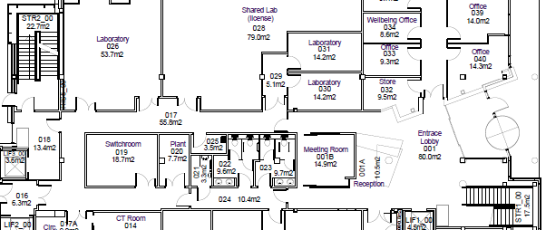

Main Entrance
030
Reception Office
001B
Figure 1. Partial floor plan of ground floor ILS1 with laboratories 026 and 030 and reception office 001B highlighted in red.

Room 030 can be accessed using the labelled access card hanging on the green access button in the reception office 001B . Refer to Figure 2. Photos of the access card hanging in the reception office, highlighted by a red circle.

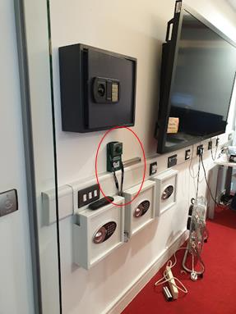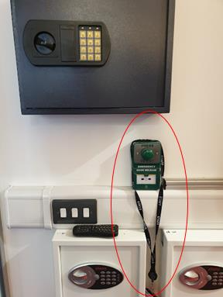
Figure 2. Views in reception office 001B showing laboratory 030 Access Card on lanyard.

When the samples have been transferred to the continency unit, the temporary storage must be labelled with details of where the samples came from, the date of transfer, PI details and where the samples are now stored within the contingency freezer. An example is shown below:

HUMAN TISSUE

Human Tissue relocated from [insert fridge/freezer location and ID]

Date of transfer:

Name of Principal Investigator:

The temporary storage of tissues are located on shelves: XXX

    - Recording an Adverse Event (HTA Relevant Material Only)
Following the failure of the storage unit used to store relevant material or any instance where tissue integrity is compromised, the Principal Investigator /or another responsible individual must submit an adverse event report in line with the HTA-CORE-SOP-Adverse Event Reporting.

Review and Amendments
Document History
Version | Review Date |  | Comment |  | Replaces |  | Reviewed by
1.0 | Add Date |  |  |  | N/A |  | Add PI name
Author |  | Name and role
 |  | Signature and date
Approver |  | Name and role |  | Add PI
 |  | Signature and date
Effective Date: |  |  |  | Next Review Date:

