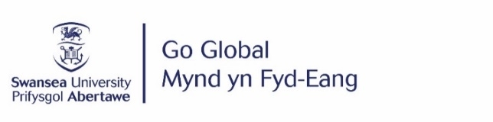
STUDY ABROAD 2024/25 APPLICATION FORM – ENGLISH LITERATURE

Full Name |  | Student Number
Degree Scheme

- Check the list of available year abroad options on our website here
- Select 10 year abroad options, ranked in order of preference below
- At least 2 must be a Group A option
- A maximum of 5 can be Taith eligible universities (Taith funding is limited and not guaranteed for all students assigned to a Taith eligible university)

Year Abroad options ranked in order of preference
1
2
3
4
5
6
7
8
9
10

⃝ Tick here if you want to be added to the Taith funding waiting list. Taith funding may become available following the 24/25 allocation process. If you tick this box, you will be considered for any unused Taith funds, even if you are allocated a destination which is not currently Taith eligible.
Personal Statement – Why do you want to study abroad? Maximum of 100 words
There is no guarantee that you will be allocated one of your chosen universities, however every effort will be made to assign students to one of their preferred options. If you are not assigned one of your preferred options, please tick here to indicate you would you be interested in being offered one of the remaining places. ⃝
Email this form to studyabroad@swansea.ac.uk by midnight on 03/12/2023
Applications received after this date will not be considered until after places have been allocated.

