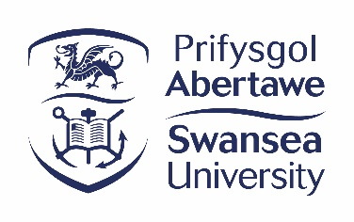
Libraries and Collections Inclusive Statement

Effective Date: December 2024
Review Date: December 2025
Approval Body: Library Leaderships Team
Policy Owner: Libraries and Collections
Policy Author: Annette Linton, Head of Library Content & Scholarly Communications, a.m.linton@swansea.ac.uk

Background / Summary
As part of its vision, Swansea University’s Libraries and Collections seeks to make its collections, services and spaces fully open, accessible and inclusive. We embrace diversity, creativity and sustainability in knowledge creation and provide access to valuable collections that inspire and inform learning and research and help develop the skills to achieve academic excellence.

We recognise that historically some of the material in our collections may include language that would now be regarded as unacceptable or inadequately reflect the diversity of our user communities. We also recognise that there is a historical over-representation within publishing of white, middle- and upper- class voices of North American, European and Australian authors (often referred to as the ‘Global North’).
.

Policy Statement

We are reviewing our collections to ensure they reflect many voices and perspectives through the following actions -
- Expanding our portfolio of content by purchasing titles and/or curated collections that reflect diversity of thought and created by people from a diverse range of nationalities and backgrounds.
- Providing students with ongoing opportunities to suggest titles via our online form.
- Supporting academics to diversify their reading lists.
- Encouraging critical thinking by highlighting titles that reflect a diversity of authorship and place of publication.
- Reviewing and revising cataloguing descriptions where appropriate.

Within current legal requirements, we do not remove, censor, or restrict access to these items which may contain offensive language or contents. We aim to provide access to a wide range of materials that represent a variety of viewpoints with sufficient context to enable our users to engage in a critical exploration of differing viewpoints in a respectful and open-minded manner. Swansea University’s Libraries and Collections does not endorse the views of any harmful or offensive material.

For further information -
https://libguides.swansea.ac.uk/diversecollections

Related Policies
Links to any related policies.
Title | Link
Swansea University Library – Content Development and Management Policy | https://www.swansea.ac.uk/media/Swansea-University-Library-Content-Management-and-Development-policy-v1.0-final-2018-06-25.pdf

Policy History

Revision Date | Author | Description
November 2024 | Library and Collections | New statement created to clarify relationship between historical content and inclusivity of library collections.

